ServiceNow Development with Flow Designer
Project Documentation format
1. Introduction
• Project Title: Streamlining IT Procurement: Automating Standard Laptop Orders with Flow Designer
• Team Members:
Team Member | Role / Activities
Nivedita R | Team Lead; creation of the flow Standard Laptop Task and the Create Catalog Task action
Kalpana R | Business use case and business requirements
Josephin silviya E | Flow assignment to the Standard Laptop catalog item (Process Engine)
Renuga D | Service Catalog order placement and request approval
Keerthana V | Testing, UAT and conclusion

2. Project Overview
• Purpose: The IT procurement process for standard laptops is largely manual, and the configuration step can be missed or delayed. This project automates the process with ServiceNow Flow Designer: when a Standard Laptop is ordered and approved, a configuration catalog task is created and assigned to the hardware team automatically, reducing manual work and the waiting time for users.
• Features: Standard Laptop item in the Service Catalog; Flow Designer flow with the Service Catalog trigger; Create Catalog Task action with Short Description, Description, Assignment Group (Hardware) and Approval; flow attached to the catalog item through Process Engine; order status and approval tracking through the Request, Requested Item and Catalog Task records.
3. Architecture
• User Interface (Service Catalog): The Standard Laptop item in the Hardware category of the Service Catalog, where the user clicks Order Now to place the request.
• Automation (Flow Designer): A flow named Standard Laptop Task (Application: Global, Run As: System User) with the Service Catalog trigger. The Create Catalog Task action uses the Requested Item record, sets the Short Description and Description, sets the Assignment Group to Hardware and sets Approval to Approved.
• Data (Records and Fields): The Request, Requested Item and Catalog Task [sc_task] records. The catalog task created by the flow has the following fields.
Field Label | Type | Reference / Value set
Number | Auto Number | Generated by ServiceNow (for example SCTASK0010001)
Request Item | Reference | Requested Item record of the order
Short Description | String | Laptop needs to be configured
Description | String | Laptop needs to be configured
Assignment Group | Reference | Hardware
Approval | Choice | Approved
State | Choice | Open (default)
Assigned to | Reference | Empty; picked up by a Hardware group member

4. Setup Instructions
• Prerequisites: A ServiceNow instance (for example, a Personal Developer Instance), an administrator account, and access to Flow Designer, Maintain Items and the Service Catalog.
• Installation: Step-by-step configuration of the solution:
1. Create the flow: open All, search for Flow Designer and select it under Process Automation. Click New > Flow, enter the flow name Standard Laptop Task, set Application to Global and Run As to System User, and click Submit.
2. Add the trigger: click Add a Trigger, search for Service Catalog, select it and click Done.
3. Add the action: under Actions click Add an Action and select Create Catalog Task. Drag the Requested Item Record into the Request Item field, enter the Short Description "Laptop needs to be configured", and add the field values Description ("Laptop needs to be configured"), Assignment Group (Hardware) and Approval (Approved). Click Done.
4. Save the flow, click Activate and confirm Activate again.
5. Attach the flow: open All > Maintain Items, search for Standard Laptop and open the record. Select Process Engine, remove the existing automations, select Flow, add Standard Laptop Task, and save the record.
6. Place a test order: open Service Catalog > Hardware > Standard Laptop and click Order Now. Note the Request Number on the Order Status page.
7. Approve the request: open the request, go to the Approvers section, right-click the approver record and click Approve.
8. Verify the result: open the Requested Item, scroll to Catalog Tasks and open the catalog task to check the Short Description and Assignment Group.
5. Folder Structure
• Service Catalog and Records: The Standard Laptop catalog item, and the Request, Requested Item and Catalog Task records created by an order.
• Flow and Process Engine: The Flow Designer flow Standard Laptop Task (trigger and Create Catalog Task action) and its link to the catalog item through Process Engine. The solution uses no custom scripts.
6. Running the Application
• Open Service Catalog > Hardware > Standard Laptop and click Order Now to place a request.
• Open the request from the Order Status page, approve it in the Approvers section, then open the Requested Item and check the Catalog Tasks section.
• Open the catalog task to check the Short Description, Assignment Group (Hardware) and Approval.
7. Flow Documentation
• The solution does not expose custom REST APIs. The automation is documented below as flow components.
Component | Configuration
Flow | Standard Laptop Task
Application / Run As | Global / System User
Trigger | Service Catalog
Action | Create Catalog Task
Table | Catalog Task [sc_task]
Request Item | Requested Item record (data pill)
Short Description / Description | Laptop needs to be configured
Assignment Group | Hardware
Approval | Approved

8. Authentication
• Users sign in to the ServiceNow instance with their own accounts. The flow runs as System User, and the request is approved by the approver from the Approvers section. No tokens or custom sessions are implemented in this project.
9. User Interface
• The user interface is the Standard Laptop item in the Service Catalog with the Order Now button.
Standard Laptop item in the Service Catalog
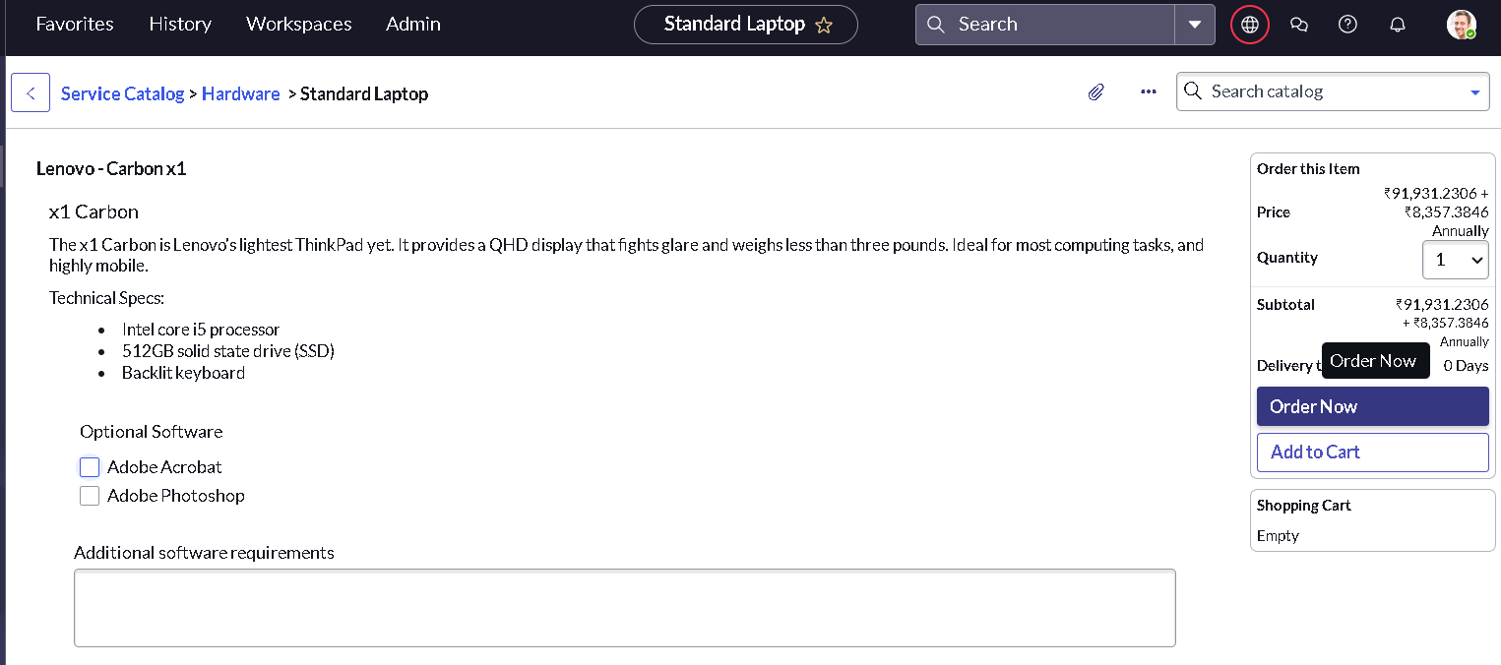

10. Testing
• Seven test cases were prepared and executed covering ordering, approval, task creation, task details and assignment group. Details are given in the Functional and Performance Testing, User Acceptance Testing and UAT Report documents. Six test cases passed and one minor text issue (BG-001) is open.
11. Screenshots or Demo
Flow Designer: Standard Laptop Task
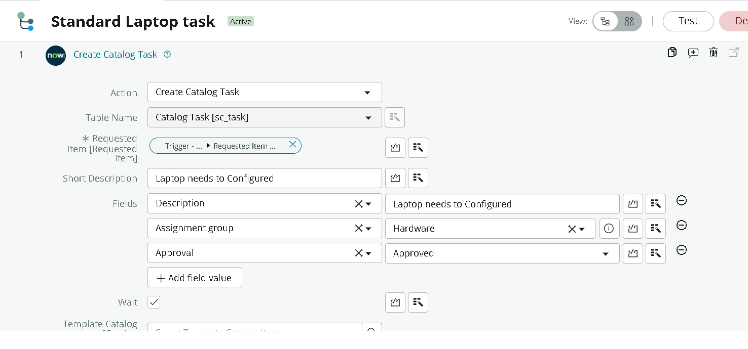

Catalog task created by the flow
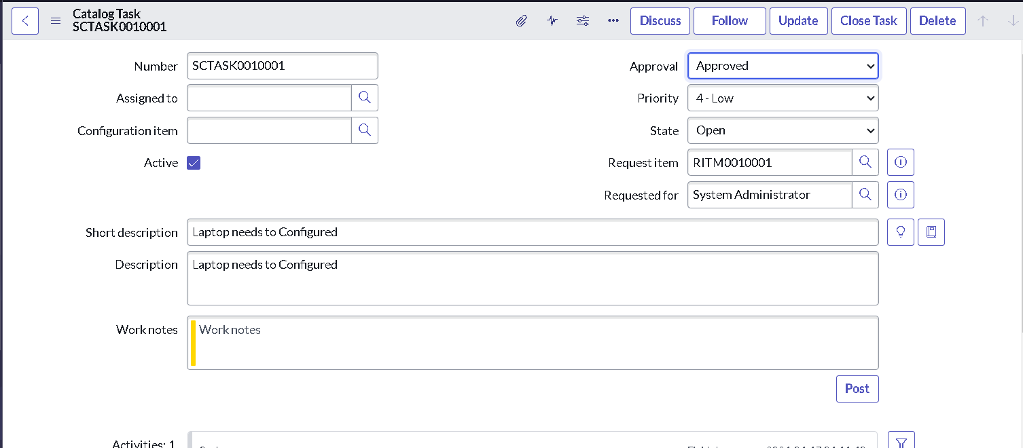

• Demo link: https://drive.google.com/file/d/1X5pETGeWrRJdmPDPQhtqd4Wl124i80uq/view?usp=drivesdk
12. Known Issues
• The Short Description and Description of the catalog task appear as "Laptop needs to be Configured" (capital C) instead of "Laptop needs to be configured" (BG-001). The value needs to be corrected in the Create Catalog Task action.
• The flow runs only for orders of the Standard Laptop item, because it is attached to that item through Process Engine. Other items need their own flows.
13. Future Enhancements
• Add an email notification to the requester, flows for other hardware items, SLA tracking and automatic approval routing. These are not part of the current implementation.

